2303A510B3
M.Priyadarshini
Assignment 20.5
Batch – 14
Lab 20 – Security Testing: Identifying Vulnerabilities in AI-Generated Code
Task 1 – Password Storage Vulnerability Check
PROMPT:
Generate a Python user registration script that stores username and password in a file or database without using hashing.
CODE:
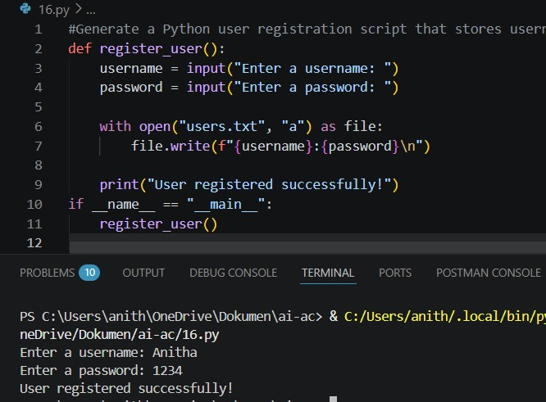
Task 2 – Hardcoded Secrets Detection
PROMPT:
Generate a Python script that connects to an external API using a hardcoded API key or credentials in the code.
CODE:
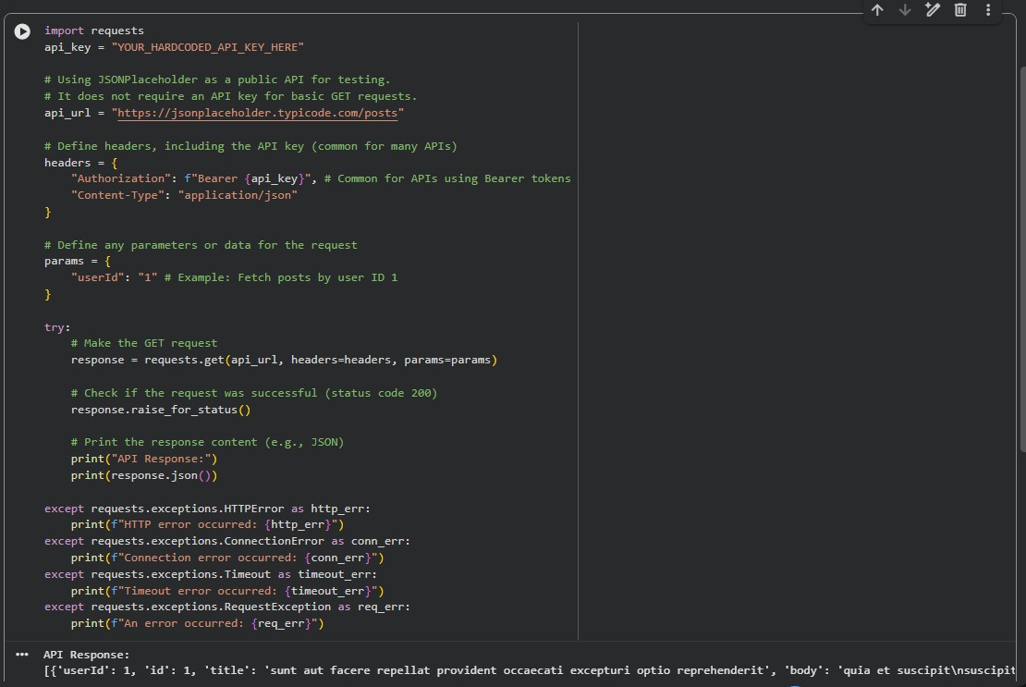
Task 3 – File Upload Security Validation
PROMPT:
Generate a simple Flask application that allows users to upload files without any validation or restrictions.

CODE:
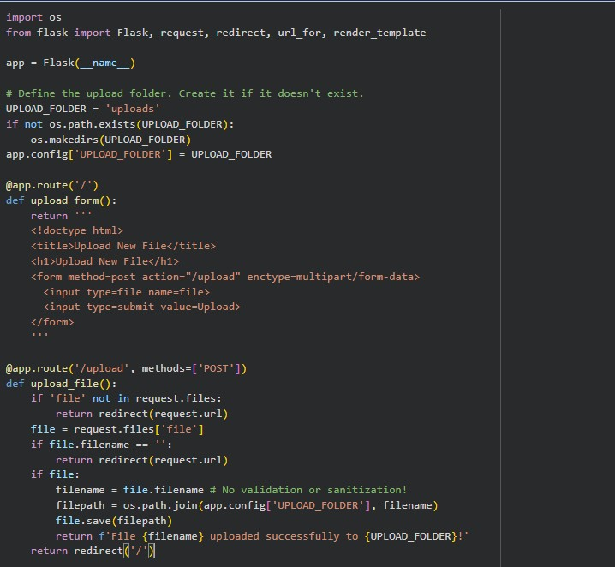

CODE:
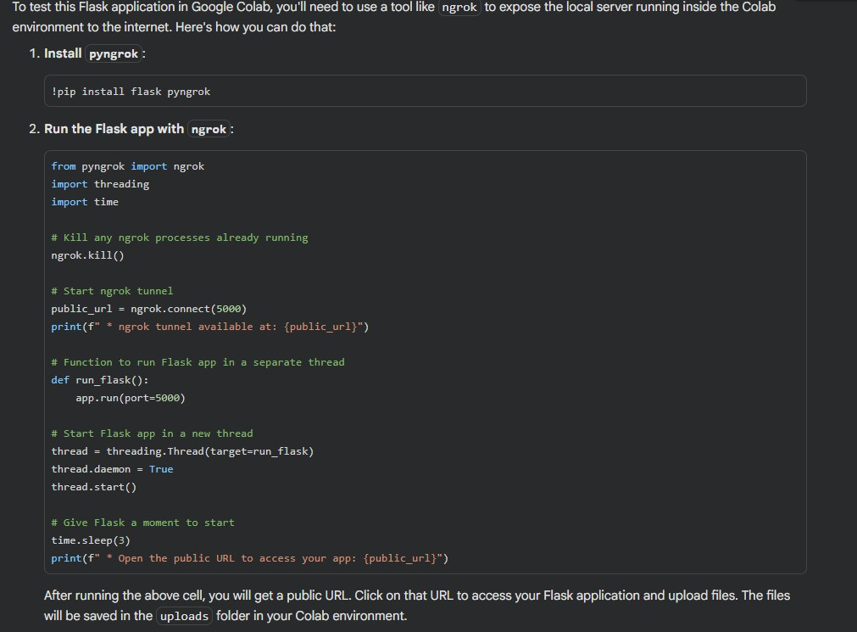
Task 4 – Command Injection Prevention
PROMPT:
Generate a Python script that takes user input and executes it as a system command using os.system() or subprocess.

CODE:
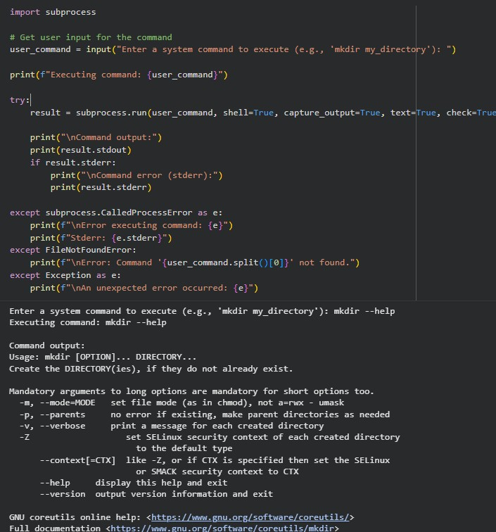
Task 5 – Secure Input Handling in Web Forms
PROMPT:
Generate a basic HTML and Flask feedback form that accepts user input and displays it without validation or sanitization.
CODE:
